# Import Retail Item Groups

This document describes the steps needed to move retail strategy/merchandise group data from a BlueCube database instance to and ESO database instance.

## Required Files

In the Retail Item Groups subject folder of the data extraction and loading package program files, there are 4 SQL scripts.

Step 1 - Retail Item Groups Extract Source DB

Step 2 - Retail Item Groups Insert Dest DB - Groups

Step 3 - Retail Item Groups Insert Dest DB - Group RMI List

Step 4 - Retail Item Groups Insert Dest DB - Group Child

Step 5 - Retail Item Groups Create Groups

## Extract Source DB

Open an instance of SQL Server Management Studio and then open a new query window. Set the database to the main BC/ESO database.

Open and Execute the query “Step 1 - Retail Item Groups Extract Source DB”. This query will create a bc_extract_retail_strategy table and populate the table with the existing set of retail strategy.

Right Click on the database names and navigate to tasks, generate scripts.

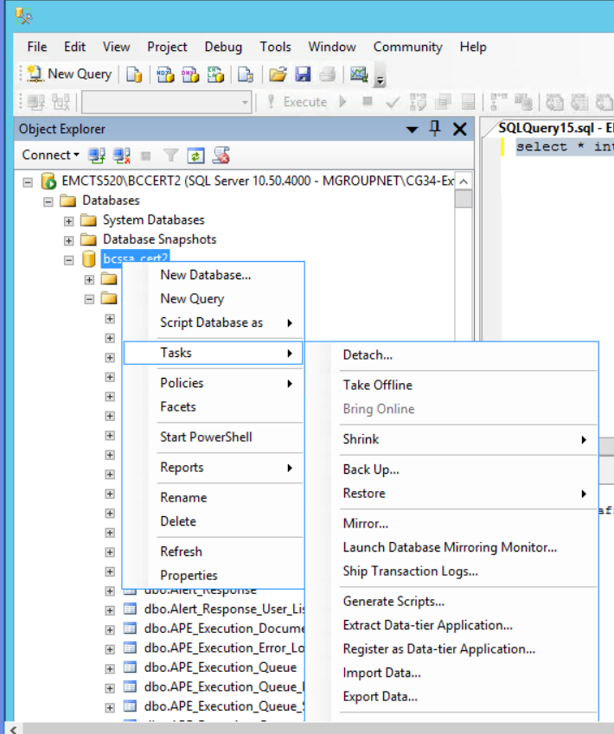

The script generation tool will be displayed.

Select the option to “Select specific database objects”. Expand the list of tables and select the tables, bc_extract_rmi_group, bc_extract_rmi_group_child, and bc_extract_rmi_group_rmi_list.

Click Next

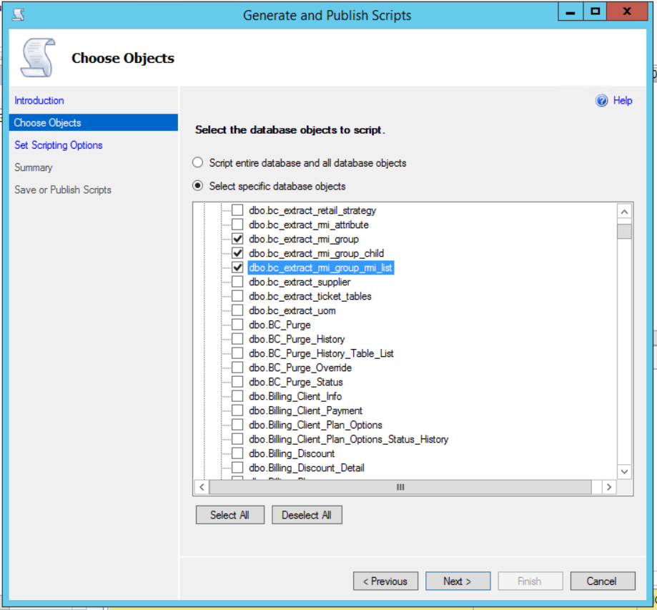

The Scripting Options page will be display, Click on the Advanced button.

Set the “Types of data to script” to “Schema and data”. Click OK.

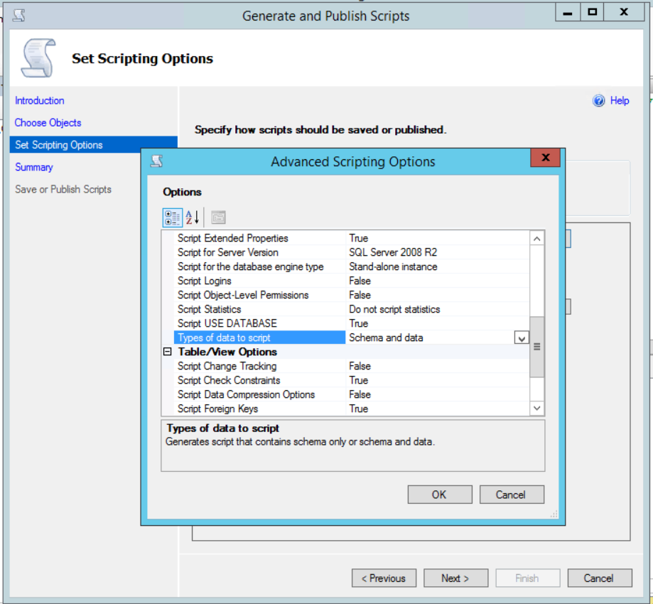

Set the option to “Save to Clipboard”. Click Next.

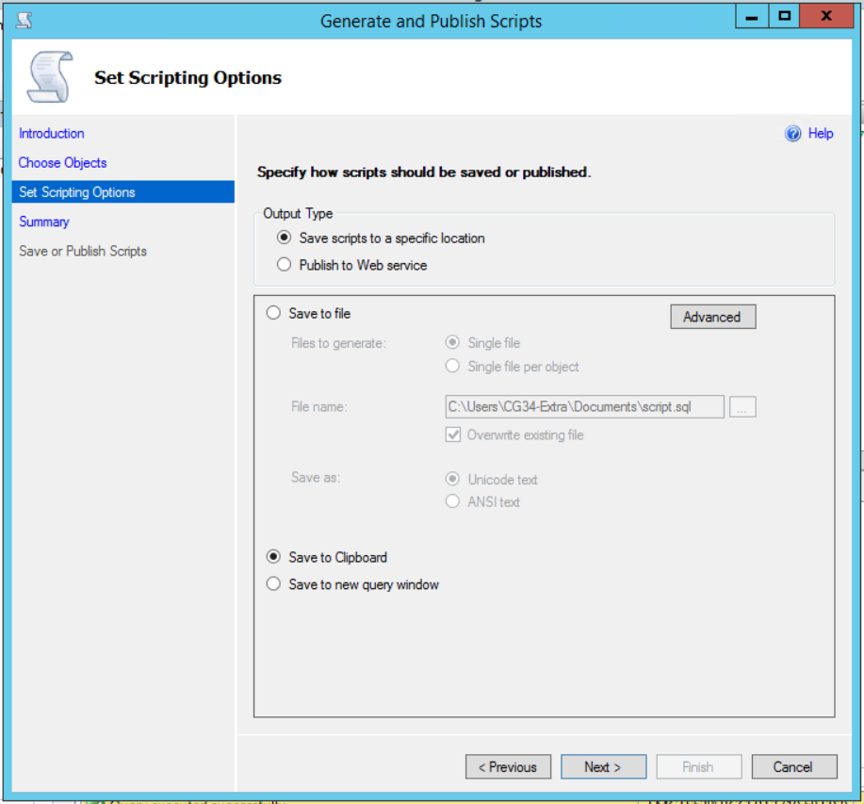

The Summary page will be displayed. Verify the information and Click Next.

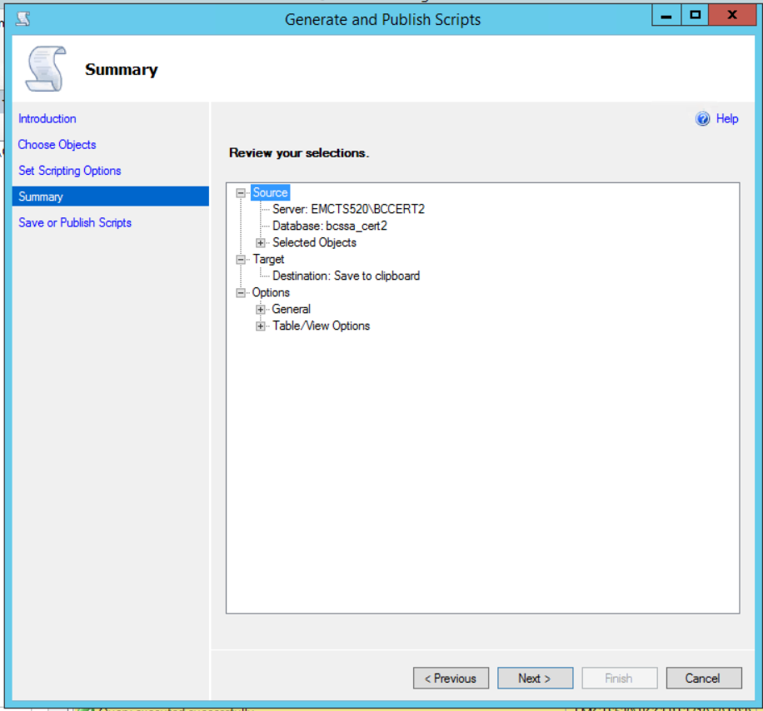

The Generate and Publish Scripts page will be displayed. Verify the result and Click Finish. The page should disappear.

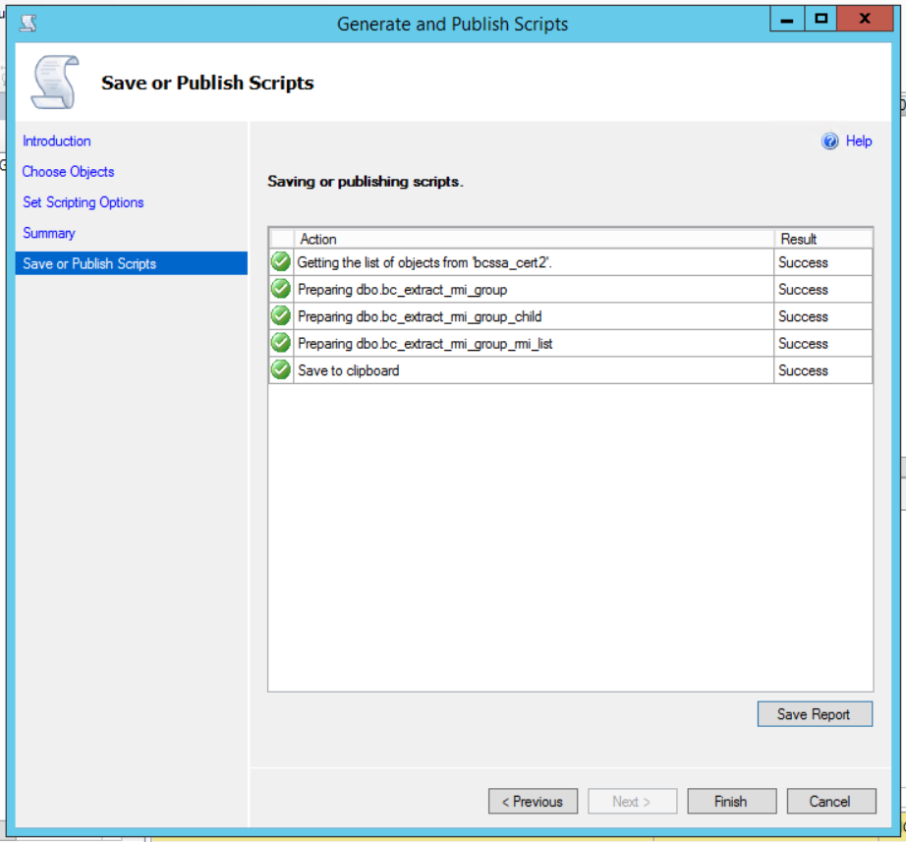

The contents of the script file are now on the clipboard.

## Insert the Destination DB.

Open up a blank file in a tex editor, and Paste the contents of the clipboard.

### Retail Item Group

Open the script “Step 2 - Retail Item Groups Insert Dest DB - Groups” in a text editor. Select All and clear the contents of the script.

Select the portion of the clipboard script that has the table create for bc_extract_rmi_group and the insert statements. Copy and to paste the information into the empty file Step 2 - Retail Item Groups Insert Dest DB - Groups.

Remove the lines of text before the create table command. It will look like this:

USE [bcssa_cert2]

GO

/****** Object: Table [dbo].[ bc_extract_rmi_group] Script Date: 11/02/2018 09:46:18 ******/

SET ANSI_NULLS ON

GO

SET QUOTED_IDENTIFIER ON

GO

Add the following to the top of the script above the create table command. This will ensure that the table is re-created:

IF OBJECT_ID('bc_extract_rmi_group ') IS NOT NULL

DROP TABLE bc_extract_rmi_group

GO

Save the Query

### Retail Item Group RMI List

Open the script “Step 3 - Retail Item Groups Insert Dest DB - Group RMI List” in a text editor. Select All and clear the contents of the script.

Select the portion of the clipboard script that has the table create for bc_extract_rmi_group_rmi_list and the insert statements. Copy and to paste the information into the empty file Step 3 - Retail Item Groups Insert Dest DB - Group RMI List.

Remove the lines of text before the create table command. It will look like this:

USE [bcssa_cert2]

GO

/****** Object: Table [dbo].[bc_extract_rmi_group_rmi_list] Script Date: 11/02/2018 09:46:18 ******/

SET ANSI_NULLS ON

GO

SET QUOTED_IDENTIFIER ON

GO

Add the following to the top of the script above the create table command. This will ensure that the table is re-created:

IF OBJECT_ID('bc_extract_rmi_group_rmi_list') IS NOT NULL

DROP TABLE bc_extract_rmi_group_rmi_list

GO

Save the Query

### Retail Item Group Child

Open the script “Step 4 - Retail Item Groups Insert Dest DB - Group Child” in a text editor. Select All and clear the contents of the script.

Select the portion of the clipboard script that has the table create for bc_extract_rmi_group_child and the insert statements. Copy and to paste the information into the empty file Step 3 - Retail Item Groups Insert Dest DB - Group RMI List.

Remove the lines of text before the create table command. It will look like this:

USE [bcssa_cert2]

GO

/****** Object: Table [dbo].[ bc_extract_rmi_group_child] Script Date: 11/02/2018 09:46:18 ******/

SET ANSI_NULLS ON

GO

SET QUOTED_IDENTIFIER ON

GO

Add the following to the top of the script above the create table command. This will ensure that the table is re-created:

IF OBJECT_ID('bc_extract_rmi_group_child') IS NOT NULL

DROP TABLE bc_extract_rmi_group_child

GO

Save the Query

## Create the Retail Item Groups

Open an instance of SQL Server Management Studio and then open a new query window. Set the database to the main BC/ESO database.

Execute each of these scripts in order (do not execute step 1 again):

Step 2 - Retail Item Groups Insert Dest DB - Groups

Step 3 - Retail Item Groups Insert Dest DB - Group RMI List

Step 4 - Retail Item Groups Insert Dest DB - Group Child

Step 5 - Retail Item Groups Create Groups

Ensure that no errors and encountered and that data was inserted into the following tables:

Retail_Modified_Item_Group

Retail_Modified_Item_Group_RMI_List

Retail_Modified_Item_Group_List

## Clean up

If needed, go to both the source and destination databases and drop the tables:

bc_extract_rmi_group

bc_extract_rmi_group_rmi_list

bc_extract_rmi_group_child